A multimodal Approach
to leverage an exploit dataset to crush a benchmark like AFC, consider a Multi-Agent / Multi-Model Architecture rather than training a single base model:
- The "Scout" Model (Trained on Code/Diffs): Train or fine-tune a model on datasets of vulnerable vs. patched C/C++ code (e.g., VulDeePecker, Big-Vul, or raw CVE commit diffs). This model acts as the static analyzer, scanning the codebase to find "Suspicious Points."
- The "Exploit" Model (Trained on Exploit-DB): Take your model trained on the Exploit dataset and use it strictly as the PoC Generator agent. Once the Scout model says, "Hey, I think there's a heap overflow here," your Exploit model uses its training to craft the precise binary blob or payload required to trigger the crash and verify it.
By isolating the exploit-trained model to the payload generation phase, we play exactly to its strengths without asking it to perform static code analysis, which it wasn't trained for.
General Concept of using multi Model Approach

We can use the architecture of AI agent for this.
Can fine tune different models on different datasets (Vulnerability and Exploits)
Then agent can call each individual model for the better output

Working Structure

Two LLMs

- One will be trained on Vul dataset to find and test if vulnerability exists)
- Second LLM will first be trained on Mapped vul and it’s exploits and then on It will be able to write runtime exploits rather the memorizing it.
- Agent can choose when to call which LLM during the process.

Exploit Training :

There are different Instruction formats that could be used to train the model.
For example
- Using Mapped Vul-exploit pairs.json to get positive results
- Use full Dataset Mapped and unmapped, for classification if for a given vul an exploit exists or not etc.
Visual Representation of the Flow

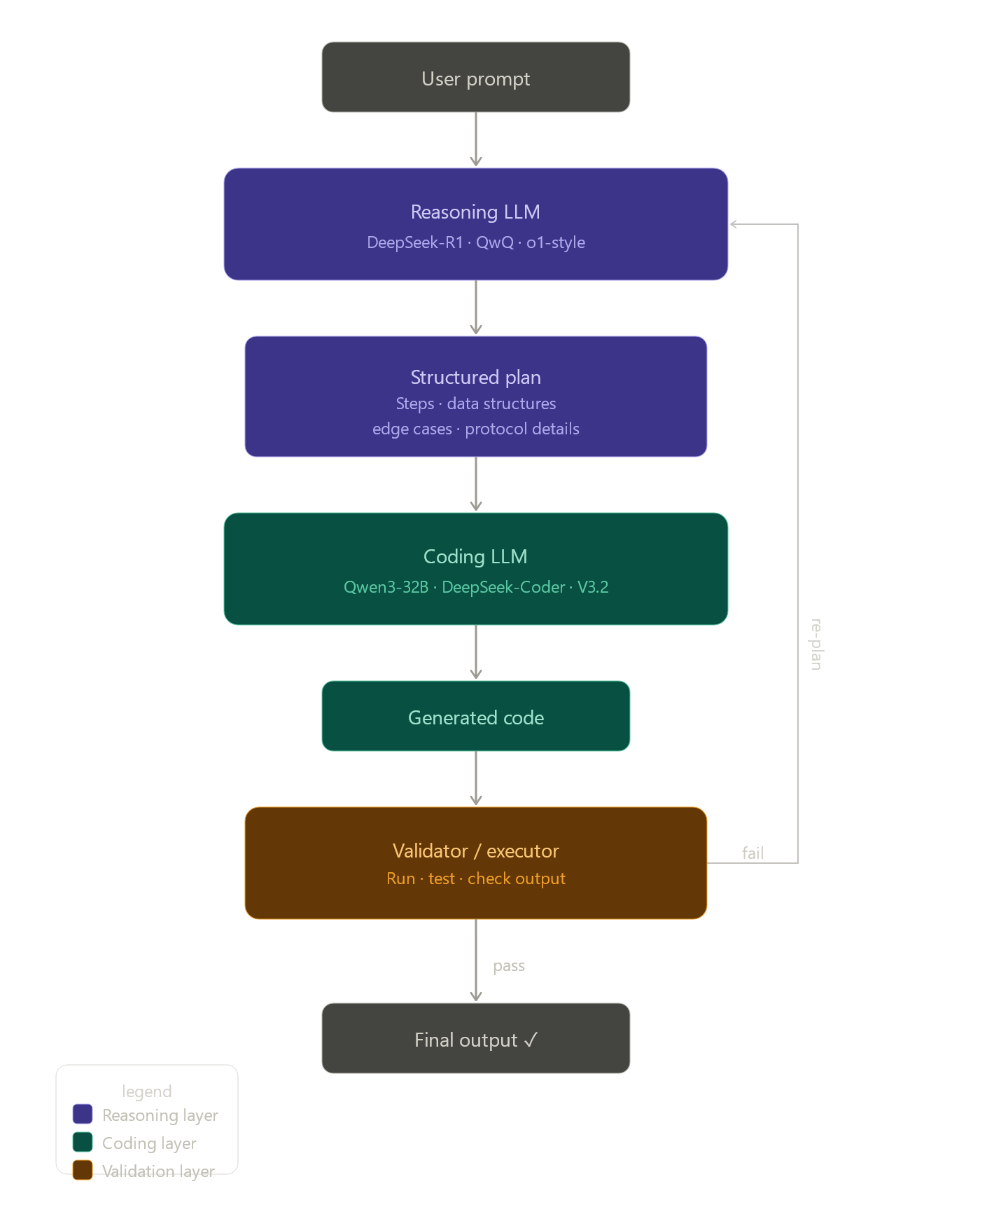

Use lora for fine tuning the vulnerability reasoning model and SFT and lora on exploit coder model

🔷 SFT Stage
With LoRA/QLoRA: Significantly reduced forgetting. Since the base weights are frozen and only small adapter matrices are trained, the original knowledge is largely preserved. This is why LoRA is the default choice for most practitioners.
🔷 DPO Stage
DPO operates on preference pairs and uses the reference model (your SFT model) as an anchor via a KL-divergence penalty
It implicitly prevents the model from drifting too far from the SFT checkpoint
With LoRA applied here too, the risk drops further
QLoRA SFT → LoRA DPO,

Findings till now using tools and LLms approach

Stage 1 : static recon tools
Using the tools of semgraph and flawfinder, we have identified 2.5 flaws out of 17 total flaws inside a .c code.
Note : the code mainly contains business flaws which are not in the domain of these tools to identify so we need to work on making these efficient in finding the static vulns first.
3/9 right now

Update: Working on Codeql tool
Results in detecting static Vulnerabilities jumped to
6/9 now.

1st debugging session : updating queries we got

Combined static + IDOR: 10 out of 14 non-pure-business-logic items (≈71%), up from the 33% we measured when this debugging session started. The remaining static gaps (hardcoded secrets via gitleaks, array OOB write) need either custom rules or a different tool class, and the remaining business-logic items are correctly out of scope for Stage 1's deterministic layer — that's exactly the boundary your architecture was designed around

